Characteristics  „Cast your bread upon the waters, for you will find it after many days…“  „Don’t wait for tomorrow about what you can do today. “  Vita  born 1954 in Murska Sobota, Slovenia, single  1978 start of professional career;  study of tailor, technician, textile technology B.Sc. & sciences, M.Sc. and Ph.D.  election to assistant (first 1983, second 1986), superior lecturer (1989),  assistant professor (1999), Associate Professor (2005)  1978 – 1983 teaching at Technical School  1983 – 1993 research and consultancy work in governmental textile institute  1983 – 1990 lecturer at University  Since 2002 Acting Manager of Slovenian Enterprise Innovators Network  since 1993 managing director of EURONITKA (EURO-LINE) Textile Research, Project Design, Consulting and Education, Ltd. Ljubljana, Slovenia - two departments Textile Institute & Consulting  since 2003 expert evaluator for European Commission in Brussels of project proposals; expert advisor and reviewer in the area of science and technology in many others government institution in Slovenia and Croatia  since 2005 member of Expert Council for Science and Technology of the government of Republic of Slovenia  member of many professional bodies in Slovenia and abroad  Hobbies: singing and music, hiking, travelling, collecting stamps etc. | 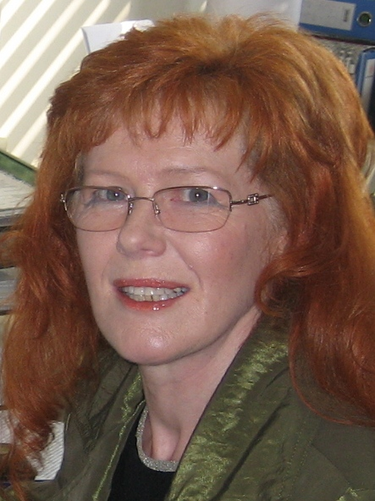  Prof. dr. sc. Dragica Kisilak, dipl.eng.  Scientist &Textile Technology Consultant  Key consultancy areas  - Research and analysis  - Technological projects and studies  - Technology & operational trainings  - Optimisation/ reorganization of textile production processes  - Technology transfer facilitator  Projects  - Scientific research work (basic and applicative) and experimental development  - National and international tenders and technological projects for textile industry  - Reorganization of garment production and integration projects (various implementation levels in preparation department and production, including planning and realization; work time standardization; quality assurance)  - Various trainings of production managers and workers  - Development of new collections (including drawing of sketches, making of patterns and sewing of design samples)

